Tenda MW5s-How to check WAN IP
Step 1: Open Tenda WiFi App and tap .

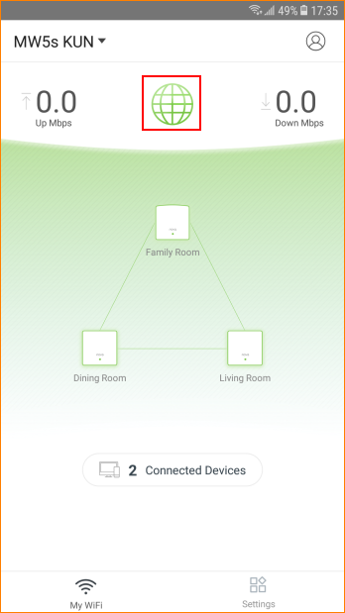

Step 2: You can check WAN IP address, Default Gateway, Primary DNS Server.
